# Response of kelp forest communities along the coast of Washington, USA to the 2014-2016 marine heatwave and sea star wasting syndrome

Tolimieri1*, Nick

Shelton1, Andrew

Samhouri1, Jameal

Harvey1, Chris,

Feist1 Blake,

Williams2, Greg

Andrews1, Kelly

Frick3, Kinsey

Lonhart4, Steve

Sullaway5, Genoa

Liu1, Owen

Berry6, Helen

Waddell7, Jenny

1Conservation Biology Division, Northwest Fisheries Science Center, NOAA Fisheries, 2725 Montlake Blvd E, Seattle WA 98112

2 Pacific States Marine Fisheries Commission, under contract to Conservation Biology Division, Northwest Fisheries Science Center, National Marine Fisheries Service, National Oceanic and Atmospheric Administration, 2725 Montlake Blvd E., Seattle, WA 98112, USA.

3Fish Ecology Division, Northwest Fisheries Science Center, NOAA Fisheries, 2725 Montlake Blvd E, Seattle WA 98112

4Monterey Bay National Marine Sanctuary, National Ocean Service, National Oceanic and Atmospheric Administration, 110 McAllister Way, Santa Cruz, CA 95060

5College of Fisheries and Ocean Sciences, University of Alaska Fairbanks, 17101 Point Lena Loop Road Juneau, AK 99801

6Aquatic Resources Division, Washington Department of Natural Resources, 1111 Washington St SE, Olympia, WA 98504-7027

7Olympic Coast National Marine Sanctuary, National Ocean Service, National Oceanic and Atmospheric Administration, 115 E. Railroad Ave. Suite #301, Port Angeles, WA 98362, USA

*Corresponding author: nick.tolimieri@noaa.gov

# Abstract

We examined the response of kelp communities along the Olympic Coast of Washington State, USA to the recent perturbations of anomalous warm-water events and sea star wasting syndrome (SSWS). Anomalously warm water in 2013 and 2014 corresponded with a loss of approximately 50% of the canopy cover of two kelps *Macrocystis pyrifera* and *Nereocystis luetkeana* in 2013-2014. However, the canopy quickly recovered to earlier levels, and stipe density increased after 2015. There was a 164-fold increase in the density of purple sea urchins *Strongylocentrotus purpuratus*, largely at one site, but this increase was observed in 2017 and peaked in 2019, well after the onset of warming, before declining somewhat in 2021. Sea stars did not show recovery from SSWS, with several species including *Pycnopodia helianthoides* continuing to decline. The majority of variation in assemblage structure occurred at the site level for kelps, macroinvertebrates, and fishes, while yearly variation explained most of the variability for juvenile rockfishes (*Sebastes* spp.). There were no strong relationships between urchins and kelp that would suggest top-down impacts of urchins on kelp abundance, except at a small spatial scale within one site. Juvenile rockfishes were more likely to occur where kelp stipe density was high. Our analyses point toward the importance of spatial variation in structuring the responses of kelp forest communities to disturbance and suggest that it is essential to ensure the protection of a diversity of kelp forests, each of which harbors habitats that can exhibit unique responses to ecological surprises yet to come.

Key Words: kelp, marine heat wave, sea star wasting syndrome, urchins, rockfish recruitment

# 1. Introduction

A rich body of literature and observation indicates that kelp forests—iconic, highly productive nearshore habitats in temperate waters throughout the world’s oceans—are susceptible to state changes from kelp dominated to urchin dominated habitat (Rogers-Bennett & Catton 2019, Beas-Luna et al. 2020, Williams et al. 2021). These state changes can be precipitated by climate and oceanographic variability (Pearse & Hines 1987), or by trophic dynamics triggered by shifts in populations and behaviors of key consumers (Watson & Estes 2011, Feehan & Scheibling 2014, Shelton et al. 2018, Dunn et al. 2021). Such sudden changes pose a risk to the wide range of valuable ecosystem functions provided by kelp forests (Smith & Fox 2021), including habitat provisioning and enhanced productivity of nearshore food webs (Duggins et al. 1989, Smith & Fox 2021), support for highly diverse and complex food webs (Gabara et al. 2021), influence on sedimentation dynamics (Connell 2005), coastal protection from wave energy (Pinsky et al. 2013), and carbon sequestration and buffering against ocean acidification (Wilmers et al. 2012, Weigel & Pfister 2021, but see Gallagher et al. 2022). By fueling nearshore production and providing extensive adult and juvenile fish habitat, kelp forests also support diverse ecological communities (Graham 2004, Schiel & Foster 2015) and important commercial, recreational and subsistence fisheries for both fish and invertebrate species (Rogers-Bennett & Catton 2019). As many ecosystem-level perturbations are anticipated to intensify under scenarios of climate and ocean change (IPCC 2022), maintaining services from kelp forests requires regional mechanistic studies to understand dynamic community responses.

Kelp forests along the west coast of North America have experienced several major perturbations in the last decade. The northeast Pacific Ocean (Baja California to Alaska) experienced a massive and prolonged marine heatwave (MHW), which developed in the southeast Gulf of Alaska in the boreal winter of 2013/2014, began to impact the nearshore in 2014 (hence our use of 2014 throughout as the start date), and persisted until 2016 (Bond et al. 2015, Cheung et al. 2016, Jacox et al. 2018, Scannell et al. 2020). This MHW had profound effects on both the offshore and nearshore ecosystem (Cavole et al. 2016, Lonhart et al. 2019, Morgan et al. 2019, Sanford et al. 2019, Cheung & Frölicher 2020), including substantial loss of kelp in some areas (Cavanaugh et al. 2019, Beas-Luna et al. 2020). The timing of the 2014-2016 MHW impacts on the nearshore environment varied with latitude, and subsequent MHWs followed in 2019, 2020, and 2021 (Bond et al. 2015, Scannell et al. 2020, Harvey et al. 2022).

Additionally, beginning in late 2013, sea star wasting syndrome (SSWS, a.k.a sea star wasting disease) impacted populations of at least 20 species of sea stars from California to Alaska (Hewson et al. 2014, Montecino-Latorre et al. 2016, Hewson et al. 2018, Hamilton et al. 2021), rapidly reducing many populations by 2014 and leading to local extinctions for some species. On the outer coast of Washington, *Pycnopodia helianthoides* (hereafter *Pycnopodia)* declined by 75% prior to 2018 and had lost 99.6 % of its population by 2020 (Hamilton et al. 2021). Some areas, particularly in northern California, experienced large increases in purple urchins, which are prolific grazers and capable of near-complete reduction of kelp stands to urchin barrens (Rogers-Bennett & Catton 2019). As some of the hardest hit sea stars (e.g., *Pycnopodia*) consume urchins, the die-off may have reduced top-down predation pressure on sea urchins. However, urchins follow well-documented boom-bust reproductive cycles (Pearse & Hines 1987, Uthicke et al. 2009, Ebert 2010), and the dramatic increase of purple urchin populations in the early 2010s, which was temporally and spatially disjunct along the northeastern Pacific, may be due to a combination of a reduction in a minor predator (sea stars, especially *Pycnopodia*; Hamilton et al. 2021), a change in foraging behavior due to a SST-driven decrease in available drift kelp (Kriegisch et al. 2019), and a numeric increase due to successful recruitment and settlement of urchin larvae.

There were large regional difference in the response of kelp forests and the degree of change to these events. Kelp cover in Oregon was either stable or increased during and following the 2014-2016 MHW (Hamilton et al. 2020), while Northern California saw substantial and persistent loss of kelp canopy and a shift to urchin barrens (Rogers-Bennett & Catton 2019, McPherson et al. 2021). Responses in Central California and the Southern California Bight were more muted, as kelp cover declined only slightly even though there were large increases in urchins in Central California (Beas-Luna et al. 2020). In Baja California, both kelp and sea urchins decreased sharply (Cavanaugh et al. 2019, Beas-Luna et al. 2020). The regionally distinctive responses of kelp forest communities are likely due to both spatial variation in climate dynamics and associated bottom-up environmental drivers (especially in relation to species’ tolerances and range margins), and regional differences in food web structure and top-down pressures (Reed et al. 2016, Cavanaugh et al. 2019, Rogers-Bennett & Catton 2019, Beas-Luna et al. 2020, Hamilton et al. 2021, Smith et al. 2021).

Kelp forests in California have been monitored regularly for decades, including the periods before and after the recent marine heatwaves, sea star die-off, and localized changes in kelp-urchin dynamics (Rogers-Bennett & Catton 2019, Beas-Luna et al. 2020). However, kelp forests along the outer coast of Washington, USA (Fig. 1) have received only sporadic attention. Past studies have documented recovery of kelp and declines in invertebrate abundance following the restoration of a keystone predator, the northern sea otter *Enhydra lutris*, to the Washington coast (Kvitek et al. 1989, Kvitek et al. 1998, Shelton et al. 2018). Less is known about interannual dynamics, including how kelp forest sites in Washington have changed in response to and following recent major perturbations. Moreover, little is known about the ecology of fish communities in these kelp stands, despite the important role of kelp habitat in the life history of multiple commercially important species in the region. For example, many Northeast Pacific rockfishes (genus *Sebastes*) settle in kelp habitats as juveniles (Ammann 2004); some species, like black rockfish *S. melanops*, remain in kelp throughout their lives, while others move to deeper areas as they mature, promoting teleconnections between nearshore and offshore environments (Love et al. 2002). Washington kelp forests are occupied by juveniles of two highly valuable commercial species, yellowtail rockfish *S. flavidus*, and canary rockfish *S. pinniger*, and by both juvenile and adult black rockfish*,* which are among the most highly valued recreational fishes in the state. In other regions, habitat complexity is known to affect the recruitment of juvenile rockfishes (Johnson 2006), and the vertical structure and canopy of kelps in particular can be especially important (Holbrook et al. 1990, Carr 1991, Markel & Shurin 2020).

Here, we examine recent kelp community dynamics at five sites along the Olympic Coast of Washington, USA, using diver surveys of kelp density and abundances of associated invertebrates and fishes from 2015-2021 (excluding 2020). We assess spatiotemporal trends and community composition patterns for the major species of macroalgae (giant kelp *Macrocystis pyrifera*, bull kelp *Nereocystis luetkeana*, stalked kelp *Pterygophora californica,* and other stipitate kelps), sea urchins, sea stars, and fishes, including juvenile rockfishes. We examine MHW timing and severity using SST. While SST is the primary parameter used to identify MHWs (Hobday et al. 2016), multiple drivers significantly influence the occurrence and nature of MHWs, and temperature extremes co-occur with changes in many interacting environmental conditions, which are difficult to disentangle (Straub et al. 2019). Specific to kelp research, SST has been used as a proxy for nutrient conditions based on experimentally derived relationships (e.g., Cavanaugh et al. 2011, Pfister et al. 2018), while other studies suggest that elevated temperatures have independent physiological impacts (Muth et al. 2019, Hamilton et al. 2020). Our main objectives were to examine: (1) if and how kelp forest communities changed in the periods during and following the 2014-2016 MHW and other warm SST anomalies, and SSWS; (2) whether community composition of kelps, invertebrates, and fishes was structured more by spatial differences or shared temporal variation; and (3) whether we can detect interactions involving multiple guilds, which are hypothesized to structure kelp forest communities. Specifically we investigate the relationship between kelp and sea urchin densities at multiple spatial scales, and assess the link between the abundance of kelp and juvenile rockfishes. Finally, we offer some hypotheses and perspective on ways that kelp forest dynamics and responses to ecosystem perturbations may differ between our study area and other coastal regions of the Northeast Pacific.

# 2. Materials & Methods

## 2.1 Study sites

We conducted dive surveys at five sites in late July or early August of 2015-2021 (but excluding 2020 due to COVID-19 restrictions) within or adjacent to Olympic Coast National Marine Sanctuary (OCNMS, designated in 1994) along the coast of Washington, USA (Fig. 1). These sites range from Destruction Island in the south to Neah Bay in the north. All sites were relatively protected from wave action, primarily subtidal rocky reefs (Fig. S1; Shelton et al. 2018), and supported the surface-canopy forming kelp species *Macrocystis pyrifera* (hereafter *Macrocystis*) and/or *Nereocystis luetkeana* (hereafter *Nereocystis*), as well as the mid-water (~ 1.5 m off the bottom) stipitate kelp *Pterygophora californica* (hereafter *Pterygophora*), and various understory kelps (Shelton et al. 2018).

## 2.2 Survey design

Our survey provides estimates of species-level abundance for four guilds in kelp forest ecosystems: (1) major macrophytes (*Macrocystis, Nereocystis*, *Pterygophora,* and ‘Other’, the sum of other stipitate macrophyes), (2) major benthic invertebrates (e.g., urchins, sea stars), (3) fishes; and (4) juvenile rockfishes *Sebastes* spp., defined here as individuals less than 10 cm total length. Divers on SCUBA conducted *in* *situ* surveys to count targeted species at each site along benthic belt transects (30 m by 2 m) following slightly modified procedures described in Malone et al. (2022). At each of the five sites (Fig. 1), we sampled two locations, separated by >100 m, and two depths within each location (5 and 10 m; in 2015 we only sampled at 5 m). We targeted completing six replicate transects at each year-site-depth combination (Table S1).

For algae and invertebrates, we surveyed a 30-m long by 2-m wide swath centered on each transect (60 m2 total area), and for fishes we surveyed a 30-m long by 2-m wide by 2-m tall volume (120 m3 total volume). We recorded all invertebrate species larger than 2.5 cm in size (maximum dimension) and all kelp stipes greater than 30 cm in height. In some instances we found high densities of kelp or invertebrates and subsampled these species. In each of three 10-m segments along a transect, we recorded the distance at which we observed 30 individuals and then converted these data to a total estimate of density for the 60 m2 transect. We counted and estimated the size (total length to nearest cm) of all fishes greater than 5 cm total length; the exception was rockfishes *Sebastes* spp., which we estimated sizes for all individuals. Rockfishes ≤10 cm were considered juveniles. Divers also estimated horizontal visibility on each transect by determining the distance at which the lead diver could distinguish their buddy’s extended fingers. Transects with visibility less than 2.0 m were excluded from the analyses including fishes, since species identification becomes imprecise.

Because it is difficult to distinguish visually many rockfish species when they are small, we categorized juvenile rockfishes into five groups established in the literature (Johansson et al 2018, Markel & Shurin 2020). Yellowtail and black (YTB) included both yellowtail *S. flavidus* and black *S. melanops* rockfishes. The copper/quillback/brown (CQB) group included copper *S. caurinus*, quillback *S. maliger*, and brown *S. auriculatus* rockfishes. We were able to identify canary *S. pinniger* and blue rockfish *S. mystinus* to species. Unidentified individuals were categorized as juvenile rockfishes.

## 2.3 Sea surface temperature (SST)

To evaluate SST trends at our sites, we obtained daily mean sea surface temperature (SST) data from the NOAA Optimum Interpolation (OI) SST V2.1 High Resolution Dataset (Reynolds et al. 2007, Huang et al. 2021) for 2003-2021 for each of the five sites (https://psl.noaa.gov/data/gridded/data.noaa.oisst.v2.highres.html). These data are available daily in a 0.25-degree latitude x 0.25-degree longitude global grid. The Neah Bay and Tatoosh sites fall within the same OISST grid cell, so their values are identical. We then calculated the mean SST for each month to identify the maximum monthly mean SST for each year (Cavanaugh et al. 2019, Hamilton et al. 2020).

## 2.4 Area of canopy kelps

We augmented our kelp stipe counts with data from aerial overflight surveys of kelp surface-canopy cover to provide a broader temporal context of how kelp canopy species responded to the MHW prior to our initiating benthic surveys in 2015. The Washington Department of Natural Resources (WDNR) conducts these surveys annually in late July or early August during peak kelp canopy coverage. Data were available for 1989-2020, excluding 1993, with area data derived from the analysis of aerial photographs (Van Wagenen 2015, WADNR 2017, Shelton et al. 2018). The survey distinguishes between *Macrocystis* and *Nereocystis*. Here we used data on the canopy area defined as the spatial extent of kelp blades, bulbs and stipes floating on the water surface (Van Wagenen 2015).

## 2.5 Data analysis

We examined the WDNR kelp data to estimate the response of canopy cover to the SST conditions at our sites, especially anomalously warm SST. These data have revealed the influence of bottom-up environmental processes and top-down forcing through trophic cascades on kelp abundance over the past 30 years (Pfister et al. 2018, Shelton et al. 2018). Here we qualitatively examined the short-term response of canopy cover from area on the outer coast of Washington and the western Strait of Juan de Fuca to Neah Bay in the years during and following the MHW to better understand changes during our study period in the context of the longer-term kelp dynamics.

To understand changes in kelp forest communities since 2015, we created a regionally aggregated time series (2015-2021) for each of the focal taxa within the four guilds of our SCUBA surveys (kelps, invertebrates, fishes, juvenile rockfishes); in some cases, rare species were combined into a larger taxon (Tables S2-S5, Fig. 2). We first averaged densities by Site and Year and then took the yearly mean of Site averages to obtain a region-wide mean for each taxon to identify any strong temporal trends at the scale of the study region (Fig. 1). As we have only six years of data, we limited our evaluation to qualitative analysis of trends in these data.

While aggregate time series are useful for understanding generalized trajectories of each species, we expect different members of the kelp forest community to have distinct spatial and temporal patterns in abundance due to differences in recruitment, other life-history characteristics, and food-web interactions. Furthermore, identifying shared spatial and temporal patterns of abundance can reveal factors important in structuring kelp forest communities. We focused on understanding the patterns of variation in each of four guilds—kelp, benthic invertebrates, large fishes, and juvenile rockfishes—and then compared factors explaining variation in abundance among guilds. We applied permutation-based, multivariate analyses to understand how each guild (see Tables S2-S5 for species included in the analyses and higher-level taxon groupings of uncommon species) was structured with respect to the three independent variables appropriate to our survey structure: Depth, Site, and Year, plus all two-way interactions with transects as replicates. Each independent variable was coded as a factor. We ordinated sites using canonical analysis of principal coordinates (CAP, implemented in R using ‘CAPdiscrim’; Anderson & Willis 2003) to visualize abundance variation. We used permutation-based multivariate analysis of variance (PerMANOVA, implemented via ‘adonis’ in R (Anderson 2001, R Core Team 2021)) to determine the variance explained by each independent variable (Depth, Site, and Year, plus all two-way interactions). Here we present the r2 values with the terms treated as fixed effects, not variance components from random effects. We applied a square-root transform to the data and used a Bray-Curtis distance matrix with 999 permutations for both the CAP and PerMANOVA analyses (Anderson 2001). We summarized results for the ordinations at the Site x Year level for presentation. We then compared results among the guilds to assess if the four guilds are structured in a similar manner that would suggest shared, cross-guild drivers.

In addition to focusing on broad taxonomic guilds, we focused on two interactions involving multiple taxa that have been identified as particularly important components of kelp forest communities. First, we investigated the relationship between sea urchins and kelp as this interaction plays a disproportionate role in determining kelp forest community structure including mediating between kelp-dominated and urchin barren states (Estes et al. 2004, Watson & Estes 2011). Second, we assessed the role kelp forests play in providing vital juvenile settlement habitat for supporting fish communities and fisheries by assessing the relationship between juvenile rockfish density and kelp abundance (Holbrook et al. 1990, Carr 1991).

We used linear regression to examine the relationship between urchins and kelp at multiple spatial scales. As sea urchins are major herbivores in this system, we expected negative relationships between urchin and kelp abundance. We assessed the relationship between total sea urchin density (summed across the three observed species, *Strongylocentrotus purpuratus*, *S. droebachiensis,* and *Mesocentrotus franciscanus*) and kelp stipe density. For the analyses, we included three kelps species and one combined taxon: each the two major surface-canopy kelps *Macrocystis* and *Nereocystis*, the mid-water canopy kelp *Pterygophora*, and the sum of other stipitate species which are mostly understory species (Table S2), at three scales: the region-scale (using the mean of the five sites in each year), the site-scale (average densities within a site in each year), and the within-site scale (average densities within a depth-zone and site in each year). Such comparisons at multiple scales allow us to consider the range of relationships that can be generated at different spatial scales and enable closer comparisons between our focal communities and those in other regions.

Finally, we tested whether the density kelp stipes (from our SCUBA surveys) explained the occurrence and abundance of juvenile rockfishes to better understand the downstream effects of any changes in kelp abundance on rockfish recruitment. We fit a hurdle model (Maunder & Punt 2004, Potts & Elith 2006) to our data because of the large number of observed zero juvenile rockfish counts in the data set. Hurdle models separate the analysis into two models: a presence/absence model and an abundance (here mean density) model, which uses only the positive observations. Predictions from the two models are then combined. Because juvenile rockfishes and kelp density were quantified on similarly located but not identical transects (see Supplementary Materials), we averaged both the densities of kelps and juvenile rockfishes by Site x Year x Depth x Location bins (hereafter, “strata”). For the occurrence portion of the hurdle model, we fit the presence/absence data with a binomial distribution and logit-link (using the ‘glmer’ package R). We considered a range of covariates as independent predictors (see next paragraph) and used weights to adjust for variation in the total volume sampled among strata (the weight for a given stratum was the total volume of fish transects of each stratum divided by the maximum value for all strata). For the abundance portion of the hurdle model, we fit complementary models using loge (mean density) of juvenile rockfish per stratum (positive observations only) using an identity link and normal distribution (‘lmer’ package in R). As above, we included transect volume per stratum as a weighting factor to account for differences in sampling effort.

We compared four model structures involving multiple kelp covariates to test whether rockfish density was related to kelp stipe abundance: (1) the sum of the all stipitate kelps, (2) the sum of the surface-canopy kelps (*Macrocystis* and *Nereocystis*) with and without *Pterygophora* and ‘other’ kelp (sum of the remaining stipitate kelps) included as separate variables*,* and (3) *Macrocystis, Nereocystis, Pterygophora,* and other kelp as individual, independent variables, including models with one to four taxa. In all models, Site and Year were included as random factors to account for spatial and temporal variation in the intensity of recruitment unrelated to kelp density. We evaluated each array of models and selected the best fit model using AICc (Burnham & Anderson 1998).

# 3. Results

## 3.1 Sea surface temperature

The warmest mean monthly SST at our sites (between 2003 and 2021) occurred in 2013 (Fig. 1a) with anomalously warm temperatures in both July and September (Figs. S2 & S3), before the development of the MHW in the boreal winter of 2013-2014 (Bond et al 2014). In 2013 the mean SST of the warmest month peaked at 15.1°C (± 1.32 s.d.), after which SST declined each year through 2017 before spiking again in 2019 to 14.9°C (± 1.11 s.d.). Thus the 2014-2016 MHW was not the predominant temperature pattern in the coastal region of our study sites. However, warm SST in 2019 does align with a 2019 MHW (Harvey et al. 2022). There were also warm periods in both 2020 and 2021; however these periods were short enough that they did not register as high when averaged by month (Figs. S2 & S3). SST was warmest at Destruction Island and coolest at Tatoosh/Neah Bay (Fig. 1a).

## 3.2 Region-wide temporal trends

The lowest kelp surface-canopy cover in the past 20 years occurred in 2013 and 2014, coincident with the anomalously warm SST in 2013 and 2014 (Fig. 1b). Surface-canopy area for both *Macrocystis* and *Nereocystis* throughout the study area dropped to 337 ha in 2014, which was 47% of the mean canopy area of the previous decade prior to high SST in 2013 (mean 2003-2012: 720 ha ± 116 sd). Canopy cover along the Washington coast quickly recovered to earlier levels (Fig. 1b, Fig. S4), averaging 645 ha (± 185 sd) for 2015-2020—or about 90% of that of the previous decade (2003-2012) prior to the warming in 2013-2014. For both canopy species *Macrocystis* and *Nereocystis*, canopy area increased from 2015 through 2020 with the annual species *Nereocystis* showing greater magnitude year-to-year variability (Figs. 1b, S4).

At the scale of our survey region, stipe density (from SCUBA surveys) for each of the three major kelp species largely followed the broad-scale patterns derived from aerial imagery. Stipe density for all three major kelp species increased two- to four-fold from 2015-2017 (Fig. 2a). *Macrocystis* and *Nereocystis* decreased in 2018, after which *Macrocystis* stipe density remained at more than twice its 2015 level. *Nereocystis* stipe density dropped in 2021 to levels similar to 2015 (Figs. 2a, S5). *Pterygophora* continued to nominally increase through 2019, but densities were largely similar for 2017-2021. At our specific dive sites, *Macrocystis* stipe density was high at Neah Bay and Cape Johnson, while *Nereocystis* was prevalent at Tatoosh Island, Destruction Island, and Cape Alava (Fig. S5). There are some differences between the canopy and stipe density data (Figs. S4 & S5), but these are likely scale issues as the aerial canopy survey covers s broader area than our stipe counts.

Density of all three urchins increased in 2017 (Fig. 2b, S6), well after the short-lived drop in kelp abundance and warm SST in 2013 and 2014. Purple urchins showed the largest increases from 0.011 urchins m-2 in 2015 to 1.8 m-2 in 2019, a 164-fold increase across the five sites. In 2021 density dropped to 0.72 m-2, which was still 65 times that of 2015. This trend was largely driven by Tatoosh Island where the density of purple urchins increased from near zero to 4.4 m-2 in the 5-m depth zone in 2021 and to 9.5 m-2 in the 10-m depth zone in 2019 before dropping to 2.2 m-2 in 2021 (Fig. S6). Increases for red and green urchins were much lower and densities of these two species declined back to earlier levels after 2017 (Fig. 2b, S6). As we searched extensively for small, hidden urchins in all years of the study, it is unlikely that the low densities from early in the study period were due to a failure to count large numbers of cryptic urchins.

Blood stars (*Henricia* spp.) and leather stars (*Dermasterias imbricata*) were relatively common in our surveys, but other species were not (Fig 2c). We saw little evidence for recovery following the declines from SSWS observed by Hamilton et al. (2021). Leather stars decreased by about fifty percent from 2015 to 2021, and we saw a total of eight *Pycnopodia*, mesopredators that consume urchins (Moitoza & Phillips 1979, Duggins 1983), over the entire six years of surveys: four in 2016, three in 2018, one in 2019, and none in 2021. Blood stars were variable but remained more or less common, while, the only stars to show any evidence of recovery were brooding stars (*Leptasterias* spp.).

We did not see strong temporal trends for most of the larger fishes (> 10 cm) with the exception of black rockfish, which increased in abundance through 2019 (Fig. 2d, Fig. S7). This increase may have been the result of strong recruitment of YTB rockfishes to most sites in 2016 (Fig. 2e). While much less abundant, other rockfish species also showed annual variation in juvenile density, but often in different years. Canary rockfish had minor peaks in 2016, 2018, and 2021, while CQB rockfishes were more abundant in 2019 and 2021 (Fig. S8).

## 3.3 Multivariate analyses of kelp forest community guilds

The factors Site, Depth, and Year and all two-way interactions explained approximately half of the total variability in each of the four guilds (range r2 = 0.32 - 0.59). The composition of the kelp, invertebrate, and fish guilds was largely driven by among-site differences as shown in the first three ordinations (CAP, Fig. 3a-f) and PerMANOVA (Fig. 4, Tables S6-S9). For the full fish assemblage, Site explained the largest proportion of variance (r2 =0.12) but this was substantially less than the explained variance by site for kelp (r2 =0.26) or invertebrates (r2 = 0.41), which is evident in Figure 3, where there is considerably less overlap among sites for kelp and invertebrates than fish. In contrast, juvenile rockfishes were driven by year-to-year variation, and Site was not important, suggesting a strong shared temporal driver of juvenile rockfishes among sites (Fig. 3g, Fig. 4).

Beyond the broad patterns in the amount of variance explained, it is valuable to understand the specific causes of variation within guilds. For kelp, Sites ordinated based on the prevalence of the mid-water canopy species *Pterygophora* (on the first axis) and also on *Macrocystis* and *Nereocystis,* the two surface-canopy kelps, which loaded in opposite directions on second axis (Fig. 3a,b). In the context of our data, this result makes sense as three sites are *Nereocystis* dominated (Tatoosh Island, Destruction Island, and Cape Alava) while the others are *Macrocystis* dominated (Neah Bay, Cape Johnson). The kelp guild also showed substantial variance explained by the depth and depth-by-site interaction (r2  = 0.10 and 0.12, respectively; Fig. 4, Table S6), which would be expected as a function of light limitation for autotrophs (Dayton et al. 1984). We found very little evidence of shared temporal effects for kelp (Year effect, r2 = 0.02), and only minor indication of site-specific year effects (Site x Year effect, r2 = 0.05), suggesting limited effects of large scale environmental drivers on the kelp community over the survey span (2015-2021), and that differences among sites in terms of which algae were present, remained consistent.

For invertebrates virtually all of the explained variance was in the Site term (Fig. 4) with sites showing clear separation in the ordination (Fig. 3c,d). Tatoosh Island clustered separately from the other sites and was distinguished by the abundance of the three urchin species (axis 1, Fig. 3c). The ordination also tracked increases in urchin densities at Destruction Island and Neah Bay from 2018 as these years ordinated negatively on the first axis, which is consistent with the significant Site x Year effect (p < 0.05, r2 = 0.07) in the PerMANOVA (Table S7). Leather stars, *Pisaster* spp., tunicates, and sea cucumbers were prevalent at Destruction Island and Cape Alava (positive loading on axis 2), while brood stars were more abundant at Neah Bay and Cape Johnson (negative loading on axis 2, notably the two lowest relief sites in Fig. S1). Depth or Site x Depth explained very little of the variance for invertebrates (r2 for both < 0.04) and only minor Year (r2 = 0.03) and Site x Year (r2 = 0.07) effects.

Variability in the fish guild was the least well explained by Site, Year, and Depth (Fig. 3e,f, Fig. 4). While Site explained the greatest proportion of the variation (r2 = 0.12) not in the residual term, there was less separation among sites in the ordinations (Fig. 3e). Neah Bay and Cape Johnson showed some separation from the other locations, whereas Tatoosh Island, Cape Alava, and Destruction Island all overlapped. Similar to the invertebrates, a minimal amount of variance was explained by Depth (r2 = 0.03) or Site x Depth (r2 = 0.05), and only slightly more was explained by Year (r2 = 0.04) or Site x Year (r2 = 0.06) (Tables S8).

For juvenile rockfishes, the ordination showed little clustering of sites (Fig. 3g,h), and most of the explained variance was in the Year term in the PerMANOVA (r2 = 0.29, Fig. 4, Table S9) with a smaller contribution from the Site x Year term (r2 = 0.07). Specifically, 2016 was a year of shared high recruitment of yellowtail and black (YTB) rockfish region-wide (Fig. 2e) and largely drives the ordination and associated loadings. This pattern shows that recruitment was temporally variable and site difference played a reduced role in terms of the intensity or assemblage of arriving recruits.

## 3.4 Urchins and kelp

We did not see strong, negative correlations between urchins and kelp across years at the coastwide scale that would suggest top-down pressure by urchins on kelp throughout our study region. Neither *Macrocystis* nor *Nereocystis* stipe densities were correlated with urchin density when averaged across the sites within a year (p > 0.05 for both, Fig. 5a), and unexpectedly we found a positive relationship between *Pterygophora* stipe density and total urchin density (Fig. 5a, r2 = 0.78, p = 0.02). Both *Pterygophora* and total urchin density increased through 2019 but then dropped in 2021 (Fig. 2b,c).

Consideration of site- and year-specific variation revealed an apparent, negative exponential relationship between *Macrocystis* stipe densities and urchins (Fig. 5b), but this relationship was driven by one site (Tatoosh Island) where *Macrocystis* was largely absent and urchins were abundant and by other sites where *Macrocystis* was present but urchin densities were near zero (Figs. S5 & S6). Consequently, it is hard to come to firm conclusions regarding this relationship. *Nereocystis* showed no obvious relationship to urchin density across sites and years (Fig. 5c). Overall, *Pterygophora* was not correlated with urchin density, but at Tatoosh Island urchins and *Pterygophora* were positively associated across years (r2 = 0.82, p= 0.03, Fig. 5d) and thus Tatoosh Island is largely responsible for the urchin-kelp relationship at the region-scale (Fig. 5a). Other kelps did not show correlations at the site scale across years (Fig. 5e). However, the scale of the axes in Figures 5b and 5d obscures positive relationships between urchin density and both *Macrocystis* and *Pterygophora* at Neah Bay (Fig. 5f), although the range of urchin density is quite small.

Because urchin densities changed the most at Tatoosh Island, we examined small-scale (transect-level) relationships between urchins and the kelps present there to determine whether increased urchin densities resulted in localized kelp loss. There was a negative relationship between urchin density and loge(*Nereocystis* stipe density) (r2 = 0.16, p = 0.002, Fig. 5g), suggesting that at this small scale, urchin herbivory may have led to patchy reductions in *Nereocystis* density.Divers did notice active grazing, and loss of stipitate kelps, along with the remaining *Pterygophora* showing heavy signs of grazing in many areas on Tatoosh. However, *Pterygophora* showed no relationship to urchins at the transect level (Fig. 5f), unlike at the site level across years. *Macrocystis* densities were too low at Tatoosh Island to conduct a parallel analysis of this canopy species.

## 3.5 Kelp density and rockfish recruitment

The probability of occurrence of juvenile rockfishes was positively correlated with the stipe density of surface-canopy kelps. The best-fit model included summed surface-canopy stipe density as a predictor (Fig. 6a, Table S10). The next best models (ΔAICc=1.39) included the sum of all kelp stipes and surface canopy plus *Pterygophora* (ΔAICc=1.74), which is qualitatively similar to the best-fit model in terms of the inclusion of most kelp. The two model including *Macrocystis* and *Nereocystis* as individual predictors (ΔAIC = 2.27) was just outside the cut off of ΔAIC = 2.0, supporting summed surface-canopy stipe density as a predictor, at least for the presence/absence model. The relationships were similar, with the summed surface-canopy or individual surface-canopy kelps all having coefficients of approximately 2.5 (Table S10 & S11). For the random effects (Table S11), Year had higher variance (5.33 ± 2.31) than did Site (3.25 ± 1.80) for the summed canopy model and similar amounts when *Macrocystis* and *Nereocystis* were included as individual predictors (5.31 ± 2.30 and 3.28 ± 1.81, respectively). For the abundance portion of the hurdle model, the model Year and Site had the lowest AICc value with the next best model 2.17 points higher. Figure 6b shows the combined hurdle model including *Macrocystis* and *Nereocystis* for the occurrence model and Site and Year abundance model.

# 4. Discussion

Wave exposure, nutrient and light availability, grazing, predator-prey dynamics, and a host of anthropogenic factors produce geographic variability and changes over time in the composition of kelp forest communities. In the northeastern Pacific Ocean, the 2014-2016 marine heatwave (MHW) had strong effects on kelp forests and associated invertebrate and fish species in some regions but not others (Cavanaugh et al. 2019, Rogers-Bennett & Catton 2019, Beas-Luna et al. 2020, Hamilton et al. 2020, McPherson et al. 2021). We provide evidence from a relatively understudied region, along the Washington coast, that spatial differences among sites were consistent across time for kelps, invertebrates, and fishes, resulting in a relatively stable community structure during and following the 2014-2016 MHW. These findings stand in contrast to other areas, like Northern California that suffered large, persistent losses in kelp canopy and increases in sea urchin densities (Rogers-Bennett & Catton 2019, Beas-Luna et al. 2020). However, we also found similarities between patterns in Washington and those observed elsewhere in the Northeast Pacific during this time period. Specifically, the composition of the juvenile rockfish community in Washington kelp forests showed clear year-to-year variation that was consistent with the idea that oceanographic forces influence larval stages of many species (Schroeder et al. 2019, Field et al. 2021) and that these offshore influences can be moderated by characteristics of nearshore habitats and kelp densities in particular (Schmitt & Holbrook 1990, Carr 1991, Markel & Shurin 2020). Filling in the gap in our knowledge along the Washington coast provides a more complete picture for kelp forest communities in the eastern Pacific and California Current ecosystem in particular and suggests paths forward for conservation and management of these important habitats and the valuable fisheries species they contain.

In our study, the assemblage structure of kelps, invertebrates, and fishes exhibited consistent differences among sites during the 2015-2021 period, and we did not see a shift to urchin-dominated habitat. This pattern is initially surprising given the strong perturbation introduced by the 2014-2016 MHW in other regions, which could have reverberated community-wide and led to a cascade of recovery dynamics (Beas-Luna et al. 2020). However, the 2014-2016 MHW was not the dominant SST feature in nearshore waters along the Washington coast. SST peaked in 2013 prior to the 2014-2016 MHW, and this peak was coincident with a short-lived drop of about 50% canopy cover (compared to the previous decade) in 2013-2014. The SST extremes in Washington (and Oregon; Hamilton et al. 2020) were lower than in Northern California, which may explain persistence of kelp-dominated habitat in Washington compared to the 90% loss in Northern California. At our sites, maximum monthly temperature reached 15.1 °C in 2013 and 14.5 °C in 2014—approximately 1.0 -1.5 °C lower than in Northern California but comparable to or slightly warmer than Oregon (Hamilton et al. 2020). Thus, although we might have expected the communities associated with kelps–which are foundation species (Lamy et al. 2020)–to track such perturbations, they did not probably due to the relatively moderate and short-term decrease in kelp cover at our sites.

We did not detect large-scale spatial differences in community structure in Washington that would suggest that sea urchins drove kelp density trends through herbivory, supporting the primary role of environmental drivers in determining kelp abundance along the Washington coast in recent decades (Pfister et al. 2018). Urchins were rare at most of our sites, likely due in part to otter predation (Shelton et al. 2018), and overall density was lower than that associated with a shift to urchin-dominated habitat in Northern California. Prior to 2014, purple urchin densities in Northern California were 0.0 - 1.7 urchins m-2, spiking to 8.2 - 12.9 urchins m-2 in 2015 and 9.2 - 24.1 urchins m−2 by 2018 (Rogers-Bennett & Catton 2019). Across our sites in Washington, mean urchin densities increased from 0.012 m-2 in 2015 to 1.8 m-2 at their maximum in 2019, which is comparable to the period prior to the shift to urchin-dominated habitat in Northern California. Moreover, the increase in urchin density on the Washington coast was most evident in 2017 and peaked in 2019, well after the 2013-2014 nadir in kelp density (during the 2003-2020 period). The availability of drift kelp appears to mediate a switch in foraging behavior by urchins from passive detritivory to active herbivory. The latter behavior may promote a shift to urchin-dominated habitats (Pearse 2006a, Kriegisch et al. 2019). When urchins were abundant, there may have been sufficient drift kelp (and potentially threat of predation by otters), to lead urchins to remain largely passive feeders.

At Tatoosh Island, however, where there was the most substantial increase in purple urchins with densities rising to 5-10 purple urchins m-2 (Fig. S6), we did see a negative relationship between purple urchins and *Nereocystis* stipe density at the transect-level that does suggest patchy, local top-down herbivory impacts. These impacts may have been mediated by habitat leading to the transect-level variability (Randell et al. 2022). Diver observations suggest that shallower areas with ridges and more complex habitat contained fewer urchins and more kelp (consistent with the depth distribution of both taxa), while other more bowl-like and flatter areas contained large numbers of urchins and less *Nereocystis.* The steeper and more complex habitat in the shallower areas of the Tatoosh site (Fig. S1) may have retained drift kelp and allowed urchins to feed as passive detritivores (Pearse 2006b, Kriegisch et al. 2019), while less retained drift kelp in the deeper areas may have caused a shift to active herbivory leading to the patchy but negative correlation between urchin density and *Nereocystis* stipe density. Interestingly, maximum monthly SST was lowest at Tatoosh Island where increases in purple urchin density were strongest. Purple urchins do show latitudinal variation in recruitment success related to SST (Okamoto et al. 2020), although previously observed patterns would have predicted higher recruitment with warmer water in more northern latitudes.

One influence we expected to observe, but did not, was shared temporal variation in the invertebrate assemblages caused by a response to the die-off of sea stars–important predators within kelp forests–due to SSWS (Burt et al. 2018). The sea star die-off began in 2013 before our data collection commenced (Montecino-Latorre et al. 2016, Hamilton et al. 2021), but off the Washington coast populations of species like *Pycnopodia* did full crash until late 2017 (declined to 75% occurrence as defined by Hamilton et al. 2021). With the exception of blood and leather stars, sea stars were uncommon; in fact, we saw only eight *Pycnopodia* over all surveys from 2015-2021 declining from four in 2016 to zero in 2021. *Pynopodia* had been common at these sites in the late 1980’s reaching densities of 0.22-0.28 m-2 (Kvitek et al. 1988), although recolonization of the Olympic Coast by sea otters had large impacts on the benthic environment (Shelton et al. 2018). The lack of any recovery of *Pycnopodia* and other sea star populations may be due to Allee effects leading to failed reproduction and to disease persistence removing any recruits (Hamilton et al. 2021). For the other invertebrates, which have been characterized by low densities since recolonization of the area by sea otters (Shelton et al. 2018), otter predation likely explains the low density and lack of temporal variation, although Allee effects may also play a part.

The lack of strong temporal variation in the assemblage structure of the analyzed fish community corresponds well with the long life spans of many of the species and the relatively moderate, and short-term, impact of ocean warming on kelps in Washington. It does stand in contrast to other regions, such as Baja California, where persistent and pervasive loss of *Macrocystis* and exceptionally warm SST led to the disappearance of as many as half of the kelp-associated fish and invertebrate species and an increase in the abundance of warmer water species (Arafeh-Dalmau et al. 2019). While the full fish community at our study sites in Washington was relatively stable temporally, we found that most of the variation in the assemblage structure of juvenile rockfishes was temporal. Interestingly, the 2016 pulse in our SCUBA surveys coincided with high abundance of winter-spawned pelagic rockfish juveniles observed by Field et al. (2021) in the northernmost portion of their survey in 2016 (Figs. 4 & 8 in Field et al. 2021) indicating the importance of large-scale oceanic processes, especially source water (Schroeder et al. 2019). Additionally, the abundance of larger (> 10 cm) black rockfish increased in from 2016-2019 following high recruitment of YTB rockfishes in 2016. Von Bertalanffy growth curves (Wallace et al. 1999) indicate age-1 males and females would be 24 cm and 18.4 cm, respectively (thus larger than our 10 cm cut off), suggesting that our SCUBA surveys may act as a leading indicator of changes in population size for this recreationally and commercially important species, although a longer time series is certainly necessary to be more confident in this conclusion.

While interannual variability explained most of the changes in the species composition of juvenile rockfishes associated with Washington kelp forests, the occurrence of juvenile rockfish, regardless of species, was positively associated with kelp densities. In our analyses (Fig. 6, Tables S10-12), juvenile rockfish presence exhibited a positive correlation with the abundance of canopy kelps (no matter which combination of kelps we considered), reinforcing the role of kelp forests as critical or essential fish habitat (NMFS 2014, PFMC 2020) for these commercially and recreationally valuable species. In other regions, there are strong relationships between juvenile rockfish and aquatic vegetation as well (Holbrook et al. 1990, Carr 1991, Markel & Shurin 2020). The vertical structure and canopy of kelps can be especially important for recruitment of larvae into nearshore areas, where it serves as shelter from predators and provides ample opportunities for foraging for prey species during a critical life stage (Carr 1991, Andrews & Anderson 2004).

Overall, this study adds insights from a relatively understudied region to a growing body of information about kelp forest communities in the Northeastern Pacific. We suggest that in Washington the combination of lower thermal stress, lower magnitude kelp canopy declines, and lower total urchin densities may have precluded a transition to a urchin barrens as in Northern California. Trophic dynamics involving the almost complete extirpation of sea stars due to SSWS may have been offset by redundancy of other important consumers, such as sea otters (Shelton et al. 2018), and affected the patterns we observed relative to those seen in other regions (Eurich et al. 2014, Beas-Luna et al. 2020, Gregr et al. 2020). Consequently, our analyses point toward the importance of spatial variation in structuring the responses of kelp forest communities to disturbance, across a range of spatial scales. From a habitat conservation perspective, this insight leads to consideration of spatial portfolio effects (Schindler et al. 2015, Thorson et al. 2018) for kelp forests, in which different locations are characterized by a diversity of community types, each of which can afford resilience to different types of shocks (McNaughton 1977, Carpenter et al. 2009). This finding is consistent with recent work suggesting that kelps themselves benefit from spatial portfolio diversification in the face of wave exposure-induced disturbance-recovery dynamics (Walter et al. 2022). From a fisheries management perspective, protection of a spatial portfolio of kelp forest locations may ensure the preservation of essential fish habitat for critical life stages of managed species (Castorani et al. 2015). For instance, increasing the probability that kelp densities remain high at multiple locations may enhance the probability of juvenile rockfishes joining these nearshore communities in years when offshore oceanographic conditions are favorable for larvae. In order to maintain sustainable fisheries, then, what is essential is not to pick and choose a small subset of kelp forests for protection, but rather to protect a diversity of kelp forests, each of which harbors habitats that can exhibit unique responses to ecological surprises yet to come.

### Acknowledgements

We thank XX anonymous reviewers, and Z .Randell for critical review. We thank the Makah Tribe and Quileute Tribe for site access; L. Antrim for getting things started; and the NOAA Dive Center, A. Hallingstad and other Olympic Coast National Marine Sanctuary staff, and USCG Station Neah Bay for logistical support. Special thanks to R.C. Wilson and B.J. Wagner.

# Literature Cited

Ammann AJ (2004) SMURFs: standard monitoring unts for the recruitment of temperate reef fishes. Journal of Experimental Marine Biology and Ecology 299:135-154

Anderson MJ (2001) A new method for non-parametric multivariate analysis of variance. Austral Ecology 26:32-46

Anderson MJ, Willis TJ (2003) Canonical analysis of principal coordinates: A useful method of constrained ordination for ecology. Ecology 84:511-525

Andrews KS, Anderson TW (2004) Habitat-dependent recruitment of two temperate reef fishes at multiple spatial scales. Marine Ecology-Progress Series 277:231-244

Arafeh-Dalmau N, Montano-Moctezuma G, Martinez JA, Beas-Luna R, Schoeman DS, Torres-Moye G (2019) Extreme Marine Heatwaves Alter Kelp Forest Community Near Its Equatorward Distribution Limit. Frontiers in Marine Science 6

Beas-Luna R, Micheli F, Woodson CB, Carr M, Malone D, Torre J, Boch C, Caselle JE, Edwards M, Freiwald J, Hamilton SL, Hernandez A, Konar B, Kroeker KJ, Lorda J, Montano-Moctezuma G, Torres-Moye G (2020) Geographic variation in responses of kelp forest communities of the California Current to recent climatic changes. Global Change Biology 26:6457-6473

Bond NA, Cronin MF, Freeland H, Mantua N (2015) Causes and impacts of the 2014 warm anomaly in the NE Pacific. Geophysical Research Letters 42:3414-3420

Burnham KP, Anderson DR (1998) Model selection and inference: a practical information-theoretic approach. Springer-Verlag, New York, NY

Burt JM, Tinker MT, Okamoto DK, Demes KW, Holmes K, Salomon AK (2018) Sudden collapse of a mesopredator reveals its complementary role in mediating rocky reef regime shifts. Proceedings of the Royal Society B-Biological Sciences 285

Carpenter SR, Folke C, Scheffer M, F.R. W (2009) Resilience: accounting for the noncomputable. . Ecology and Society 14:13

Carr MH (1991) Habitat selection and recruitment of an assemblage of temperate zone reef fishes. Journal of Experimental Marine Biology and Ecology 146:113-137

Castorani MCN, Reed DC, Alberto F, Bell TW, Simons RD, Cavanaugh KC, Siegel DA, Raimondi PT (2015) Connectivity structures local population dynamics: a long-term empirical test in a large metapopulation system. Ecology 96:3141-3152

Cavanaugh KC, Reed DC, Bell TW, Castorani MN, Beas-Luna R (2019) Spatial Variability in the Resistance and Resilience of Giant Kelp in Southern and Baja California to a Multiyear Heatwave. Frontiers in Marine Science 6

Cavanaugh KC, Siegel DA, Reed DC, Dennison PE (2011) Environmental controls of giant-kelp biomass in the Santa Barbara Channel, California. Marine Ecology Progress Series 429:1-17

Cavole LM, Demko AM, Diner RE, Giddings A, Koester I, Pagniello CMLS, Paulsen ML, Ramirez-Valdez A, Schwenck SM, Yen NK, Zill ME, Franks PJS (2016) Biological Impacts of the 2013-2015 Warm-Water Anomaly in the Northeast Pacific. Oceanography 29:273-285

Cheung WWL, Frölicher TL (2020) Marine heatwaves exacerbate climate change impacts for fisheries in the northeast Pacific. Scientific Reports 10:6678

Cheung WWL, Frolicher TL, Asch RG, Jones MC, Pinsky ML, Reygondeau G, Rodgers KB, Rykaczewski RR, Sarmiento JL, Stock C, Watson JR (2016) Building confidence in projections of the responses of living marine resources to climate change. ICES Journal of Marine Science 73:1283-1296

Connell SD (2005) Assembly and maintenance of subtidal habitat heterogeneity: synergistic effects of light penetration and sedimentation. Marine Ecology Progress Series 289:53-61

Dayton PK, Currie V, Gerrodette T, Keller BD, Rosenthal R, Tresca DV (1984) Patch dynamics and stability of some California kelp communities. Ecological Monographs 54:253-289

Duggins DO (1983) Starfish Predation and the Creation of Mosaic Patterns in a Kelp-Dominated Community. Ecology 64:1610-1619

Duggins DO, Simenstad CA, Estes JA (1989) Magnification of Secondary Production by Kelp Detritus in Coastal Marine Ecosystems. Science 245:170-173

Dunn RP, Samhouri JF, Baskett ML (2021) Transient dynamics during kelp forest recovery from fishing across multiple trophic levels. Ecological Applications 31

Ebert TA (2010) Demographic patterns of the purple sea urchin *Strongylocentrotus purpuratus* along a latitudinal gradient, 1985–1987. Marine Ecology Progress Series 406:105-120

Estes JA, Danner EM, Doak DF, Konar B, Springer AM, Steinberg PD, Tinker MT, Williams TM (2004) Complex trophic interactions in kelp forest ecosystems. Bulletin of Marine Science 74:621-638

Eurich JG, Selden RL, Warner RR (2014) California spiny lobster preference for urchins from kelp forests: implications for urchin barren persistence. Marine Ecology Progress Series 498:217-225

Feehan CJ, Scheibling RE (2014) Effects of sea urchin disease on coastal marine ecosystems. Marine Biology 161:1467-1485

Field JC, Miller RR, Santora JA, Tolimieri N, Haltuch MA, Brodeur RD, Auth TD, Dick EJ, Monk MH, Sakuma KM, Wells BK (2021) Spatiotemporal patterns of variability in the abundance and distribution of winter-spawned pelagic juvenile rockfish in the California Current. Plos One 16

Gabara SS, Konar BH, Edwards MS (2021) Biodiversity loss leads to reductions in community-wide trophic complexity. Ecosphere 12:e03361

Gallagher JB, Shelamoff V, Layton C (2022) Seaweed ecosystems may not mitigate CO2 emissions. ICES Journal of Marine Science

Graham MH (2004) Effects of Local Deforestation on the Diversity and Structure of Southern California Giant Kelp Forest Food Webs. Ecosystems 7:341-357

Gregr EJ, Christensen V, Nichol L, Martone RG, Markel RW, Watson JC, Harley CDG, Pakhomov EA, Shurin JB, Chan KMA (2020) Cascading social-ecological costs and benefits triggered by a recovering keystone predator. Science 368:1243-+

Hamilton SL, Bell TW, Watson JR, Grorud-Colvert KA, Menge BA (2020) Remote sensing: generation of long-term kelp bed data sets for evaluation of impacts of climatic variation. Ecology 101

Hamilton SL, Saccomanno VR, Heady WN, Gehman AL, Lonhart SI, Beas-Luna R, Francis FT, Lee L, Rogers-Bennett L, Salomon AK, Gravem SA (2021) Disease-driven mass mortality event leads to widespread extirpation and variable recovery potential of a marine predator across the eastern Pacific. Proceedings of the Royal Society B: Biological Sciences 288:20211195

Harvey CJ, Garfield T, Williams G, Tolimieri N (eds) (2022) 2021-2022 California Current ecosystem status report: A report of the NOAA California Current Integrated Ecosystem Assessment Team (CCIEA) to the Pacific Fishery Management Council, March 13, 2022

Hewson I, Bistolas KSI, Quijano Cardé EM, Button JB, Foster PJ, Flanzenbaum JM, Kocian J, Lewis CK (2018) Investigating the Complex Association Between Viral Ecology, Environment, and Northeast Pacific Sea Star Wasting. Frontiers in Marine Science 5

Hewson I, Button JB, Gudenkauf BM, Miner B, Newton AL, Gaydos JK, Wynne J, Groves CL, Hendler G, Murray M, Fradkin S, Breitbart M, Fahsbender E, Lafferty KD, Kilpatrick AM, Miner CM, Raimondi P, Lahner L, Friedman CS, Daniels S, Haulena M, Marliave J, Burge CA, Eisenlord ME, Harvell CD (2014) Densovirus associated with sea-star wasting disease and mass mortality. Proc Natl Acad Sci U S A 111:17278-17283

Holbrook SJ, Carr MH, Schmitt RJ, Coyer JA (1990) Effect of Giant Kelp on Local Abundance of Reef Fishes: The Importance of Ontogenetic Resource Requirements. Bulletin of Marine Science 47:104-114

Huang B, Liu C, Banzon V, Freeman E, Graham G, Hankins B, Smith T, Zhang H-M (2021) Improvements of the Daily Optimum Interpolation Sea Surface Temperature (DOISST) Version 2.1. Journal of Climate 34:2923-2939

IPCC (2022) Climate change 2022: Impacts, adaptation and vulnerability. Summary for policy makers. Sixth assessment report. Intergovernmental panel on clmate change

Jacox MG, Alexander MA, Mantua NJ, Scott JD, Hervieux G, Webb RS, Werner FE (2018) Forcing of Multiyear Extreme Ocean Temperatures That Impacted California Current Living Marine Resources in 2016. Bulletin of the American Meteorological Society 99:S27-S33

Johnson DW (2006) Predation, habitat complexity, and variation in density-dependent mortality of temperate reef fishes. Ecology 87:1179-1188

Kriegisch N, Reeves SE, Flukes EB, Johnson CR, Ling SD (2019) Drift-kelp suppresses foraging movement of overgrazing sea urchins. Oecologia 190:665-677

Kvitek RG, Iampietro P, Bowlby CE (1998) Sea Otters and Benthic Prey Communities: A Direct Test of the Sea Otter as Keystone Predator in Washington State. Marine Mammal Science 14:895-902

Kvitek RG, Shull D, Canestro D, Bowlby E, Troutman B (1988) Changies in rocky subtidal communities within a gradient of sea otter predation along the Olympic Peninsula Coast, Washington State. 1987 Coperative Agreement between Olumpic National Park, Washington Sate Department of Wildlife and Rikk G. Kvitek. University of Washington, Seattle.

Kvitek RG, Shull D, Canestro D, Bowlby EC, Troutman BL (1989) Sea Otters and Benthic Prey Communities in Washington State. Marine Mammal Science 5:266-280

Lamy T, Koenigs C, Holbrook SJ, Miller RJ, Stier AC, Reed DC (2020) Foundation species promote community stability by increasing diversity in a giant kelp forest. Ecology 101:e02987

Lonhart SI, Jeppesen R, Beas-Luna R, Crooks JA, Lorda J (2019) Shifts in the distribution and abundance of coastal marine species along the eastern Pacific Ocean during marine heatwaves from 2013 to 2018. Marine Biodiversity Records 12:13

Love MS, Yoklavich M, Thorsteinson L (2002) The rockfishes of the Northeast Pacific. University of California Press, Berkley and Los Angeles

Malone DP, Davis K, Lonhart SI, Parsons-Field A, Caselle JE, Carr MH (2022) Large scale, multi-decade monitoring data from kelp forest ecosystems in California and Oregon (USA). Ecology n/a:e3630

Markel RW, Shurin JB (2020) Contrasting effects of coastal upwelling on growth and recruitment of nearshore Pacific rockfishes (genus Sebastes). Canadian Journal of Fisheries and Aquatic Sciences 77:950-962

Maunder MN, Punt AE (2004) Standardizing catch and effort data: a review of recent approaches. Fisheries Research 70:141-159

McNaughton SJ (1977) Diversity and Stability of Ecological Communities: A Comment on the Role of Empiricism in Ecology. The American Naturalist 111:515-525

McPherson ML, Finger DJI, Houskeeper HF, Bell TW, Carr MH, Rogers-Bennett L, Kudela RM (2021) Large-scale shift in the structure of a kelp forest ecosystem co-occurs with an epizootic and marine heatwave. Communications Biology 4:298

Moitoza DJ, Phillips DW (1979) Prey defense, predator preference, and nonrandom diet: The interactions between Pycnopodia helianthoides and two species of sea urchins. Marine Biology 53:299-304

Montecino-Latorre D, Eisenlord ME, Turner M, Yoshioka R, Harvell CD, Pattengill-Semmens CV, Nichols JD, Gaydos JK (2016) Devastating Transboundary Impacts of Sea Star Wasting Disease on Subtidal Asteroids. PLoS One 11:e0163190

Morgan CA, Beckman BR, Weitkamp LA, Fresh KL (2019) Recent Ecosystem Disturbance in the Northern California Current. Fisheries 44:465-474

Muth AF, Graham MH, Lane CE, Harley CDG (2019) Recruitment tolerance to increased temperature present across multiple kelp clades. Ecology 100

NMFS (2014) Endangered and Threatened Species: Designation of Critical Habitat for thePuget Sound/Georgia Basin Distinct Population Segments of Yelloweye Rockfish, Canary Rockfish and Bocaccio. National Marine Fisheries Service ,Federal Register 79 FR 68041.

Okamoto DK, Schroeter SC, Reed DC (2020) Effects of ocean climate on spatiotemporal variation in sea urchin settlement and recruitment. Limnology and Oceanography 65:2076-2091

Pearse JS (2006a) Ecological role of purple sea urchins. Science 314:940-941

Pearse JS (2006b) Perspective - Ecological role of purple sea urchins. Science 314:940-941

Pearse JS, Hines AH (1987) Long-Term Population-Dynamics of Sea-Urchins in a Central California Kelp Forest - Rare Recruitment and Rapid Decline. Marine Ecology Progress Series 39:275-283

Pfister CA, Berry HD, Mumford T, Randall Hughes A (2018) The dynamics of Kelp Forests in the Northeast Pacific Ocean and the relationship with environmental drivers. Journal of Ecology 106:1520-1533

PFMC (2020) Pacific coast groundifhs fishery management plan: for the California, Oregon, and Washington groundfish fishery. Pacific Fishery Management Council, 7700 NE Ambnassador Place, Suite 101, Portland, OR, 97220

Pinsky ML, Guannel G, Arkema KK (2013) Quantifying wave attenuation to inform coastal habitat conservation. Ecosphere 4:art95

Potts JM, Elith J (2006) Comparing species abundance models. Ecological Modelling 199:153-163

R Core Team (2021) R: A language and environment for statistical computing. R Foundation for Statistical Computing, Vienna, Austria. URL <https://www.R-project.org/>.

Randell Z, Kenner M, Tomoleoni J, Yee J, Novak M (2022) Kelp-forest dynamics controlled by substrate complexity. Proceedings of the National Academy of Sciences 119:e2103483119

Reed D, Washburn L, Rassweiler A, Miller R, Bell T, Harrer S (2016) Extreme warming challenges sentinel status of kelp forests as indicators of climate change. Nature Communications 7

Reynolds RW, Smith TM, Liu C, Chelton DB, Casey KS, Schlax MG (2007) Daily High-Resolution-Blended Analyses for Sea Surface Temperature. Journal of Climate 20:5473-5496

Rogers-Bennett L, Catton CA (2019) Marine heat wave and multiple stressors tip bull kelp forest to sea urchin barrens. Sci Rep 9:15050

Sanford E, Sones JL, García-Reyes M, Goddard JHR, Largier JL (2019) Widespread shifts in the coastal biota of northern California during the 2014–2016 marine heatwaves. Scientific Reports 9:4216

Scannell HA, Johnson GC, Thompson L, Lyman JM, Riser SC (2020) Subsurface Evolution and Persistence of Marine Heatwaves in the Northeast Pacific. Geophysical Research Letters 47:e2020GL090548

Schiel DR, Foster MS (2015) The Biology and Ecology of Giant Kelp Forests. University of California Press, Berkeley, CA

Schindler DE, Armstrong JB, Reed TE (2015) The portfolio concept in ecology and evolution. Frontiers in Ecology and the Environment 15:257-263

Schmitt RJ, Holbrook SJ (1990) Contrasting effects of giant kelp on dynamics of surfperch populations. Oecologia 84:419-429

Schroeder ID, Santora JA, Bograd SJ, Hazen EL, Sakuma KM, Moore AM, Edwards CA, Wells BK, Field JC (2019) Source water variability as a driver of rockfish recruitment in the California Current Ecosystem: implications for climate change and fisheries management. Canadian Journal of Fisheries and Aquatic Sciences 76:950-960

Shelton AO, Harvey CJ, Samhouri JF, Andrews KS, Feist BE, Frick KE, Tolimieri N, Williams GD, Antrim LD, Berry HD (2018) From the predictable to the unexpected: kelp forest and benthic invertebrate community dynamics following decades of sea otter expansion. Oecologia 188:1105-1119

Smith EAE, Fox MD (2021) Characterizing energy flow in kelp forest food webs: a geochemical review and call for additional research. Ecography

Smith JG, Tomoleoni J, Staedler M, Lyon S, Fujii J, Tinker MT (2021) Behavioral responses across a mosaic of ecosystem states restructure a sea otter-urchin trophic cascade. Proc Natl Acad Sci U S A 118

Straub SC, Wernberg T, Thomsen MS, Moore PJ, Burrows MT, Harvey BP, Smale DA (2019) Resistance, Extinction, and Everything in Between – The Diverse Responses of Seaweeds to Marine Heatwaves. Frontiers in Marine Science 6

Thorson JT, Scheuerell MD, Olden JD, Schindler DE (2018) Spatial heterogeneity contributes more to portfolio effects than species variability in bottom-associated marine fishes. Proceedings of the Royal Society B: Biological Sciences 285:20180915

Uthicke S, Schaffelke B, Byrne M (2009) A boom–bust phylum? Ecological and evolutionary consequences of density variations in echinoderms. Ecological Monographs 79:3-24

Van Wagenen RF (2015) Washington Coastal kelp resources—port townsend to the Columbia River, summer 2014. Washington Department of Natural Resources, Olympia.

WADNR (2017) Kelp monitoring—Olympic Peninsula, Washington State Department of Natural Resources, Olympia, WA. <http://data-wadnr> .opend ata.arcgi s.com/datas ets/kelp-monit oring -olympic-penin sula Accessed: 1 Sept 2017.

Wallace FR, Hoffmann A, Tagart J (1999) Status of the black rockfish resource in 1999. Pacific Fishery Management Council

Walter JA, Castorani MCN, Bell TW, Sheppard Lawrence W, Cavanaugh KC, Reuman DC (2022) Tail-dependent spatial synchrony arises from nonlinear driver–response relationships. Ecology Letters 00:1-13

Watson J, Estes JA (2011) Stability, resilience, and phase shifts in rocky subtidal communities along the west coast of Vancouver Island, Canada. Ecological Monographs 81:215-239

Weigel BL, Pfister CA (2021) The dynamics and stoichiometry of dissolved organic carbon release by kelp. Ecology 102:e03221

Williams JP, Claisse JT, Pondella DJ, II, Williams CM, Robart MJ, Scholz Z, Jaco EM, Ford T, Burdick H, Witting D (2021) Sea urchin mass mortality rapidly restores kelp forest communities. Marine Ecology Progress Series 664:117-131

Wilmers CC, Estes JA, Edwards M, Laidre KL, Konar B (2012) Do trophic cascades affect the storage and flux of atmospheric carbon? An analysis of sea otters and kelp forests. Frontiers in Ecology and the Environment 10:409-415

# Figures

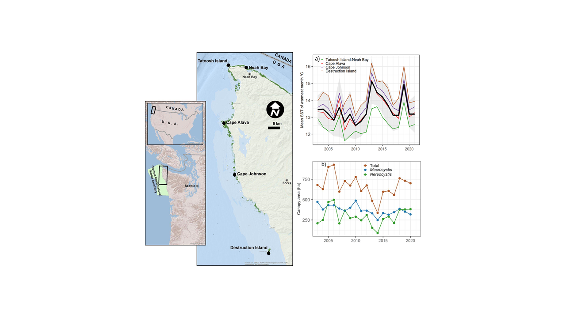

##### Figure 1. Location of the five study sites with distribution of floating kelp shown in green. Plots on right (2003-2021) are: a) Mean SST of the warmest month averaged across the five sites, and b) total area of kelp canopies floating on the surface within the Olympic Coast National Marine Sanctuary (the outer coast of Washington and the western Strait to Neah Bay). Black line in (a) is the mean across sites; colored lines are mean SST of the warmest month by site; gray envelope is +/- 1.0 s.d.

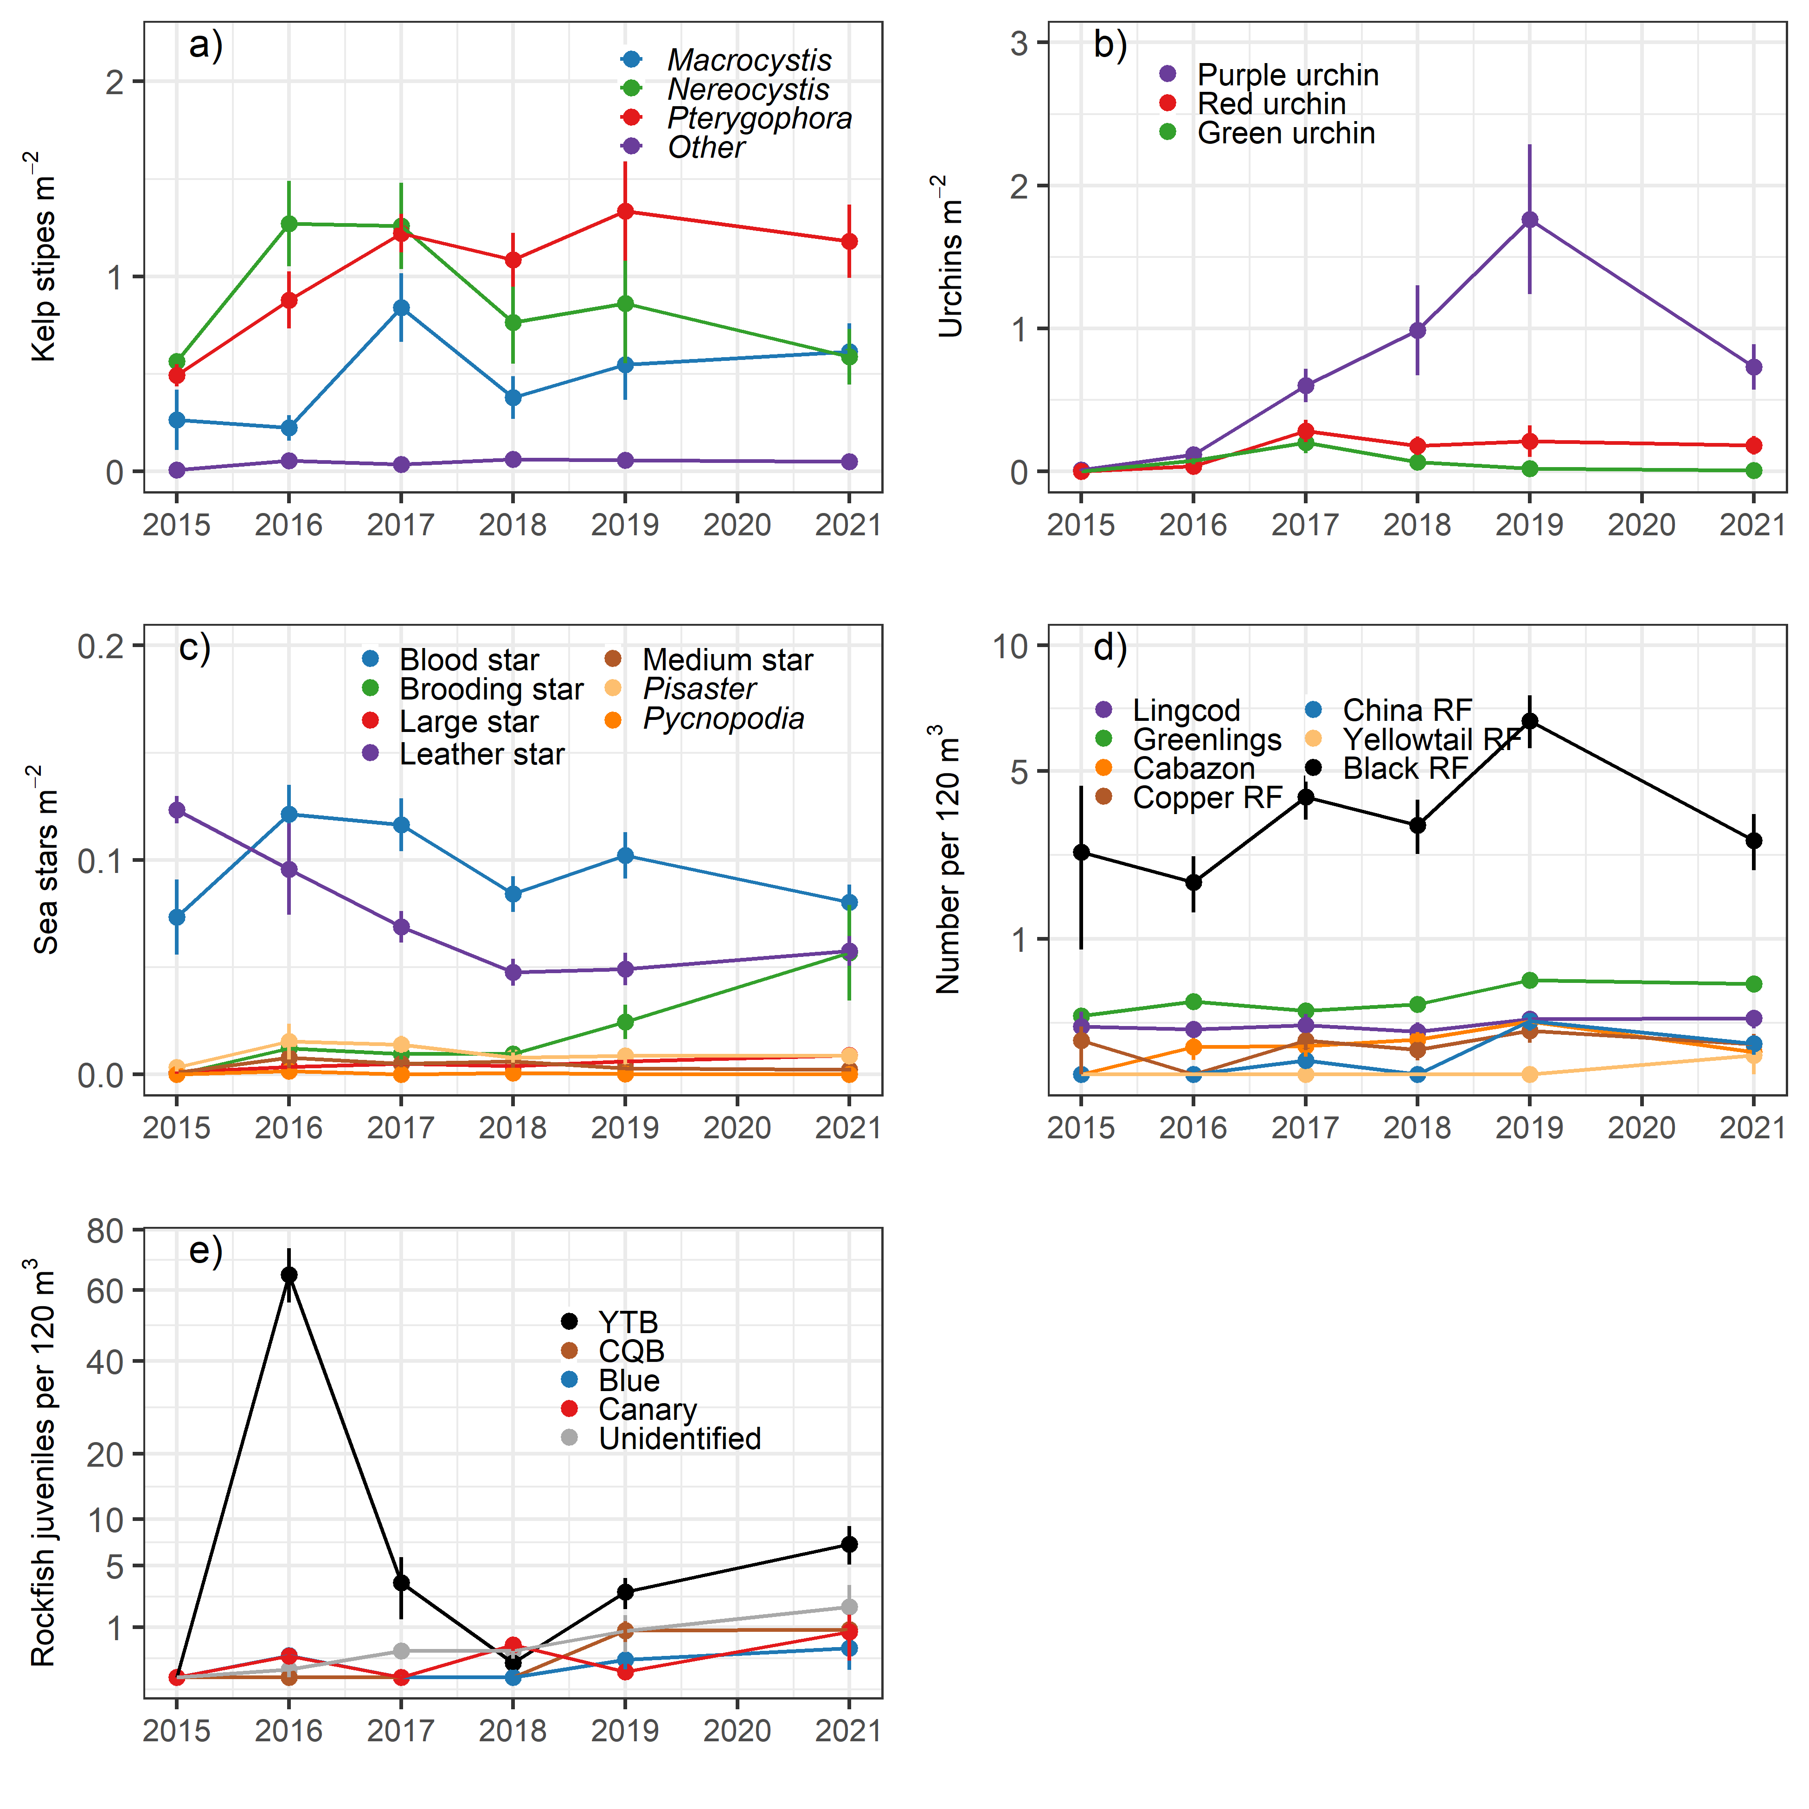

##### Figure 2. Time series of the focal groups coastwide from dive surveys from 2015-2021. a) density of kelp stipes, b) urchin density, c) sea star density, d) fish abundance, and e) abundance of juvenile rockfishes. For sea stars see Table S3 for species included in the medium and large sea star categories.

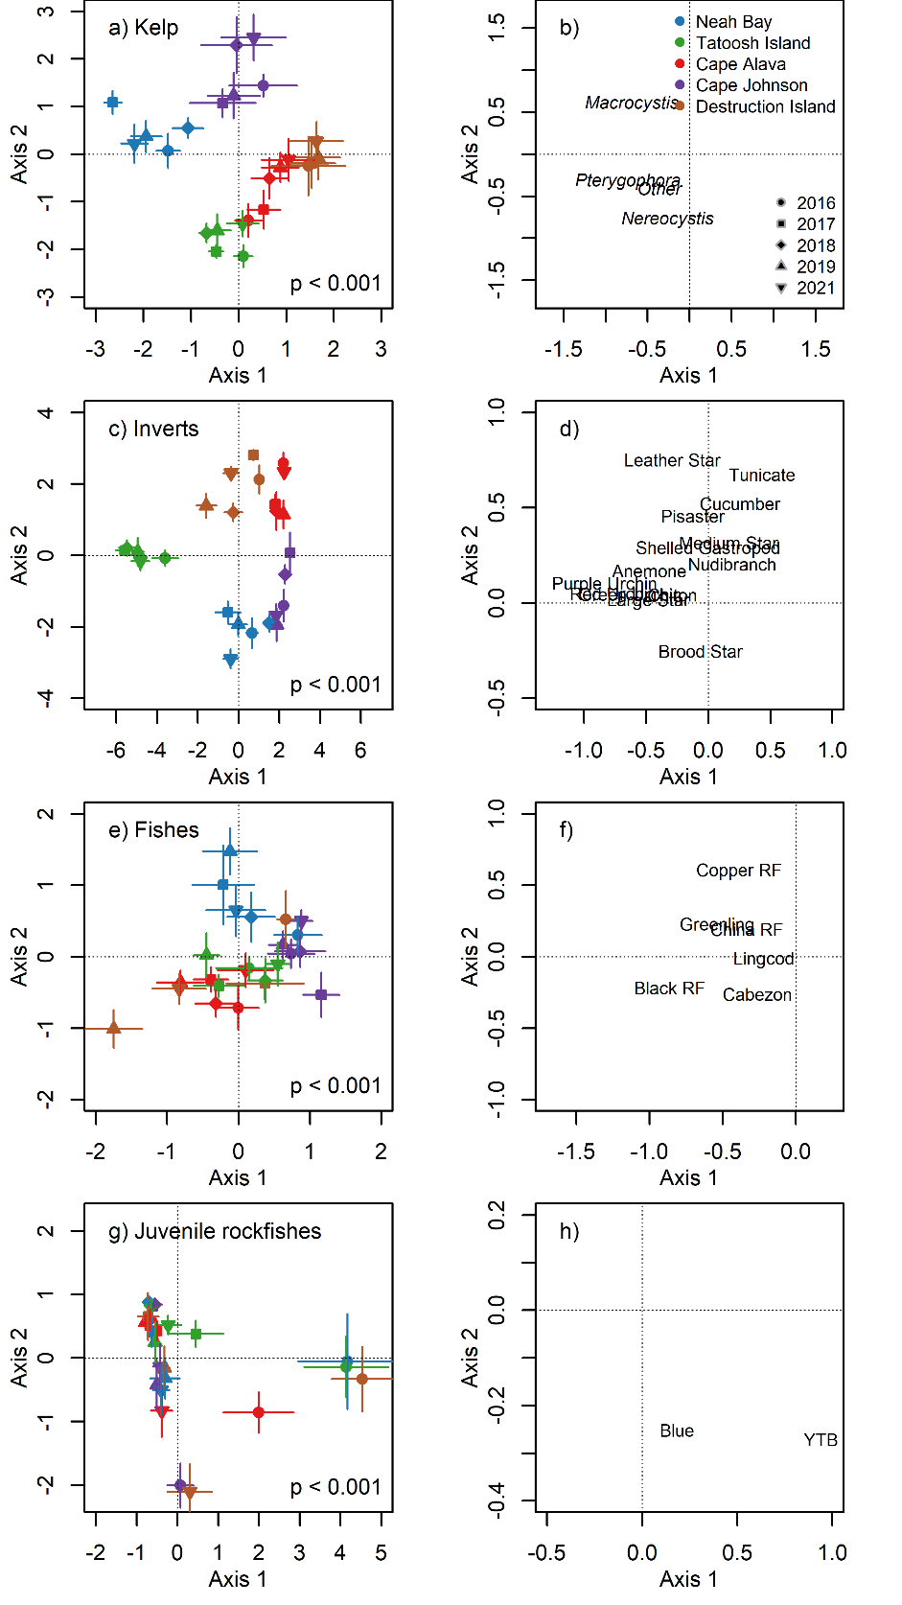

##### Figure 3. Results of canonical analysis of principal coordinates (CAP) of the assemblage structure of four guilds: kelps, invertebrates, fishes, and juvenile rockfishes. Left panes (a,c,e,g) show the ordination of Site x Year averages and p-values for the CAP analysis. Right panes (b,d,f,h) show the loadings for each taxon. RF = rockfish, YTB = yellowtail and black rockfishes.

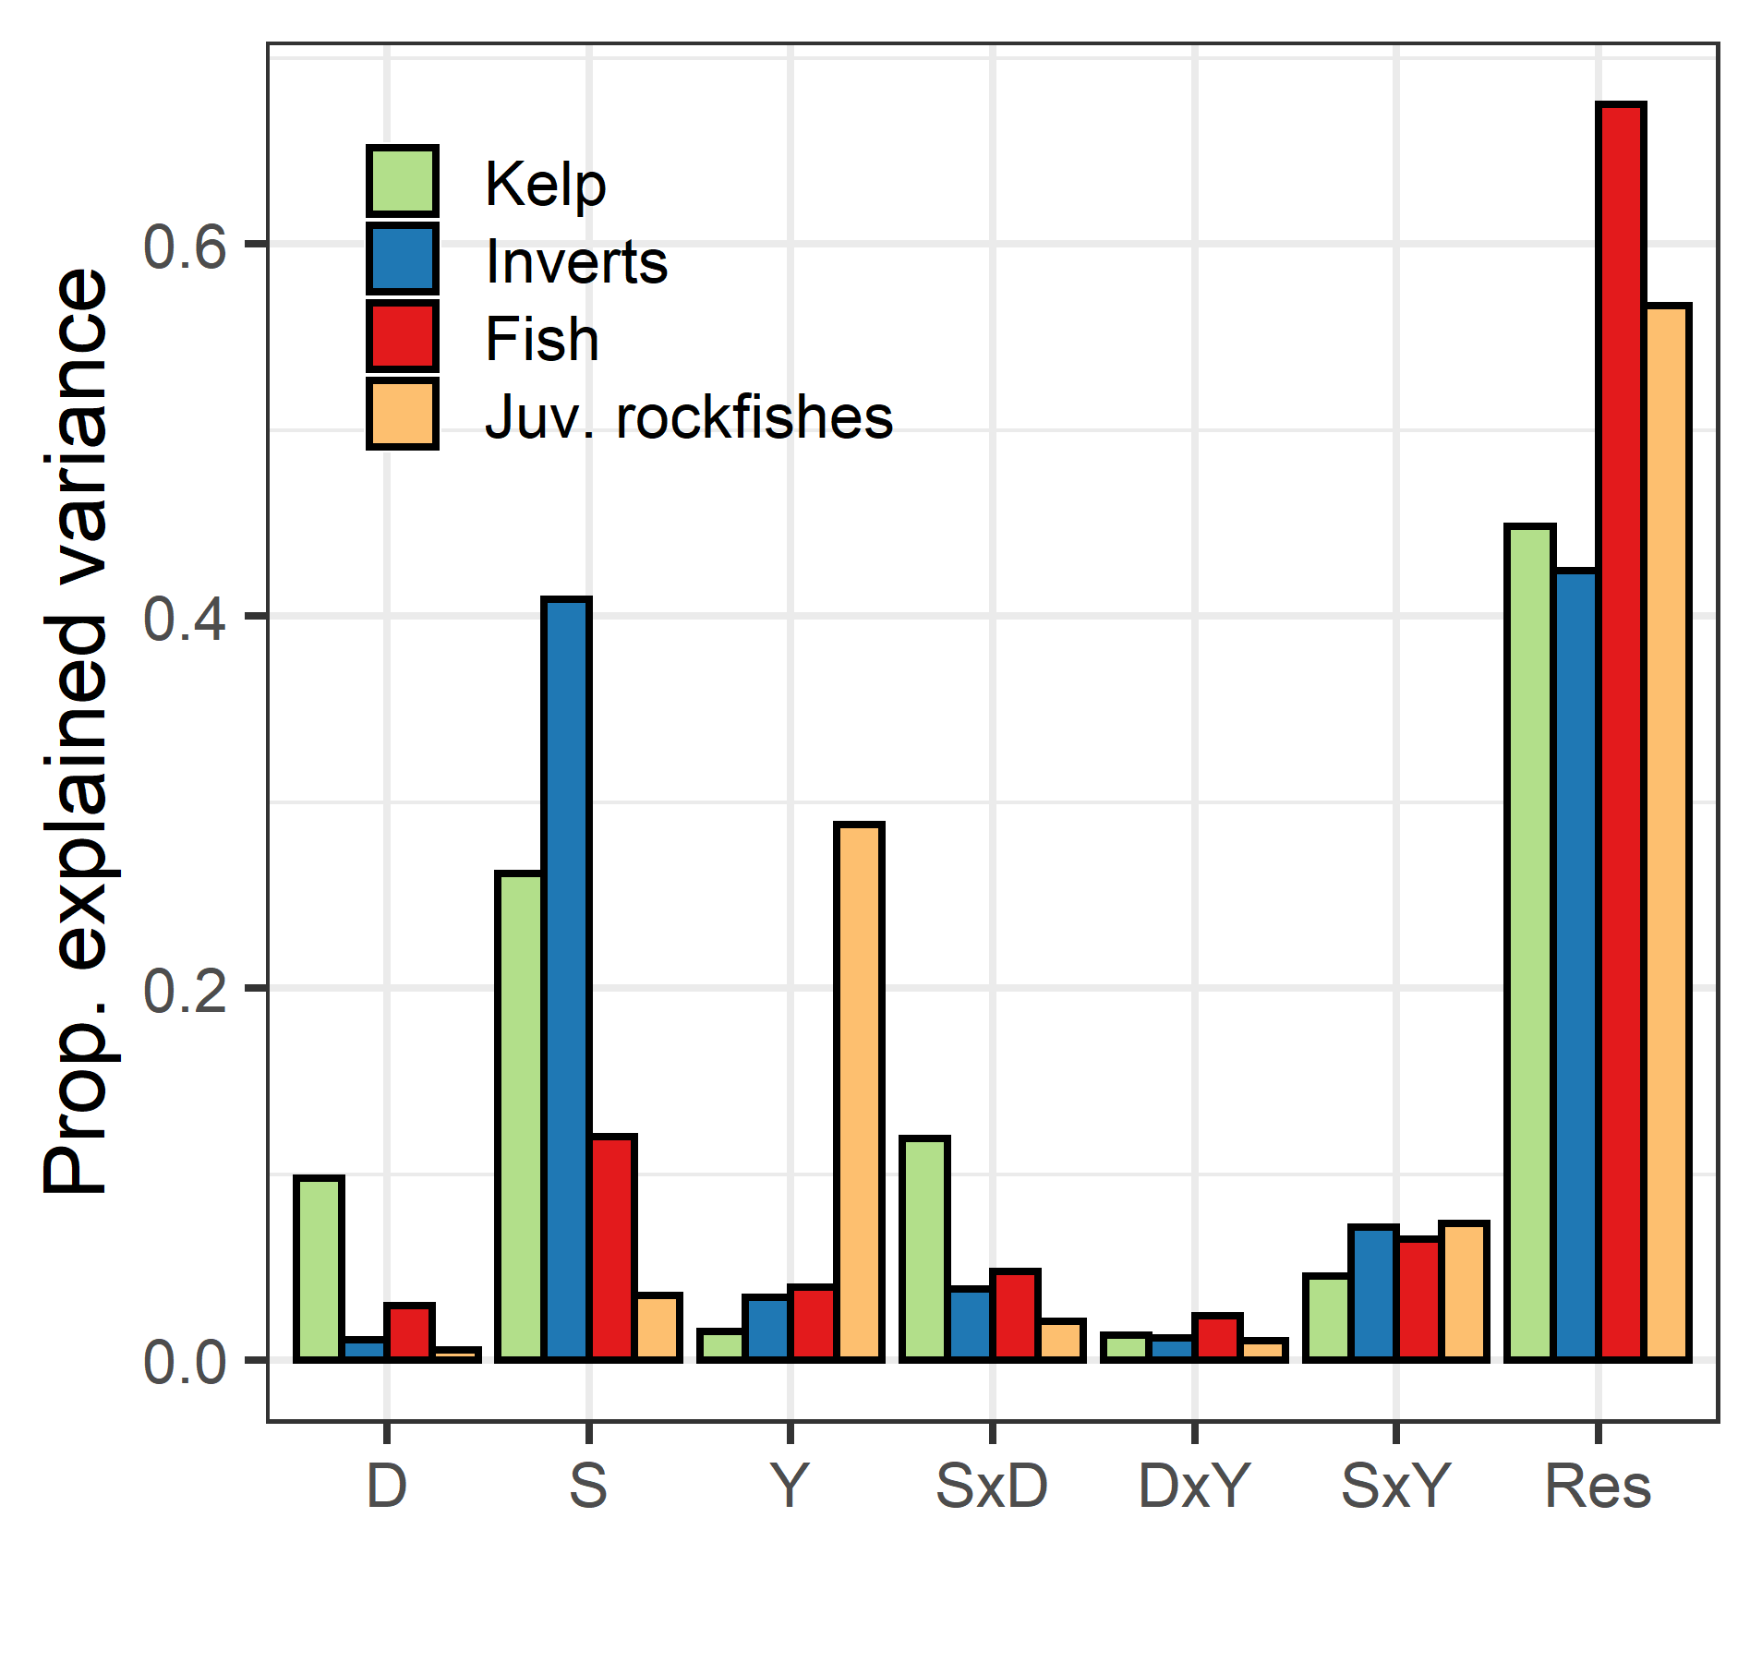

##### Figure 4. Explained variation from permutation-based multivariate analysis of variance (PerMANOVA) for four guilds: kelp, invertebrates, fish, and juvenile rockfishes. All terms are fixed effects and results are the r2 values. D = depth, S = site, Y = year, Res = Residual.

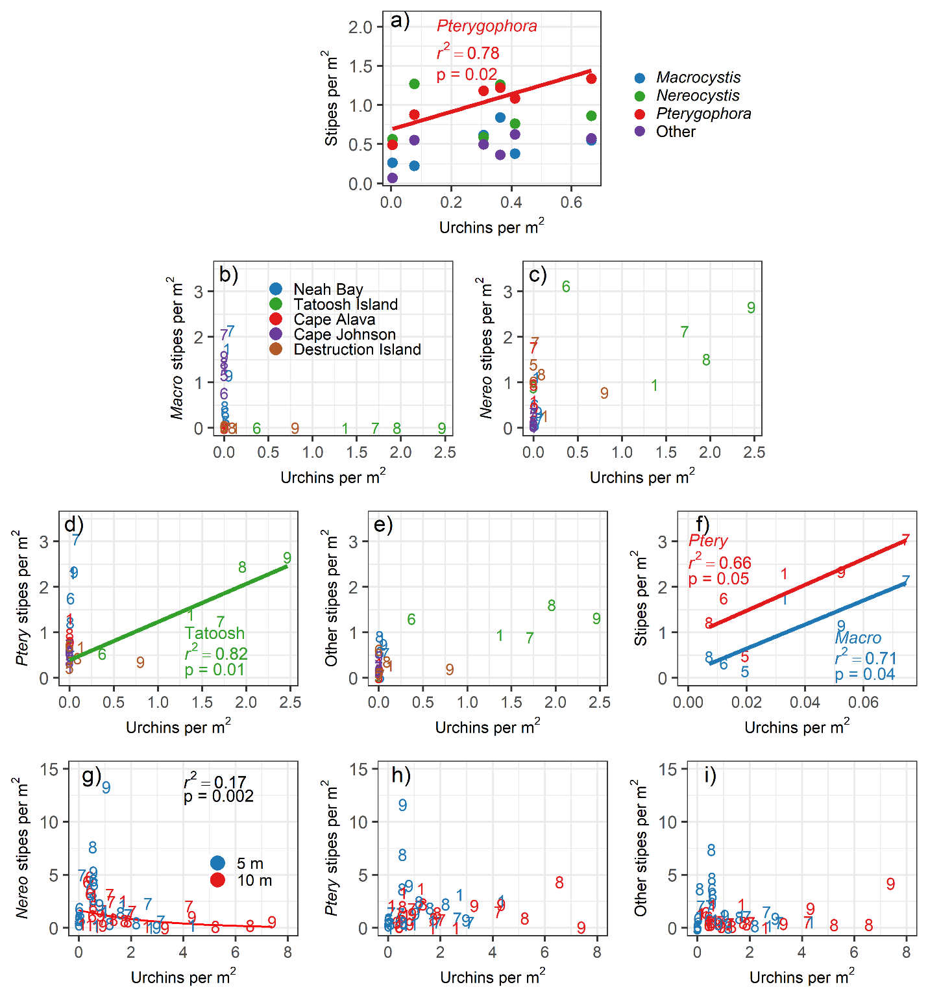

##### Figure 5. Relationship between the density of kelp stipes and total urchin density at different spatial scales: a) coastwide across years; Site by Year means for b) *Macrocystis*, c) *Nereocystis,* d) *Pterygophora,*, e) other stipitate kelps, and f) for *Macrocystis* and *Pterygophora* at Neah Bay to show pattern obscured by the scale in other panes; and at the transect level at Tatoosh Island for g) *Nereocystis,* h) *Pterygophora*, and ii) other stipitate kelps*.* For panel f the regression was for loge(Nereo stipes) = Urchin density. In panels b-i, numbered points refer to the year of data collection: 5 = 2015; 6 = 2016; 7 =2017; 8 = 2018; 9 =2019; 1=2021.

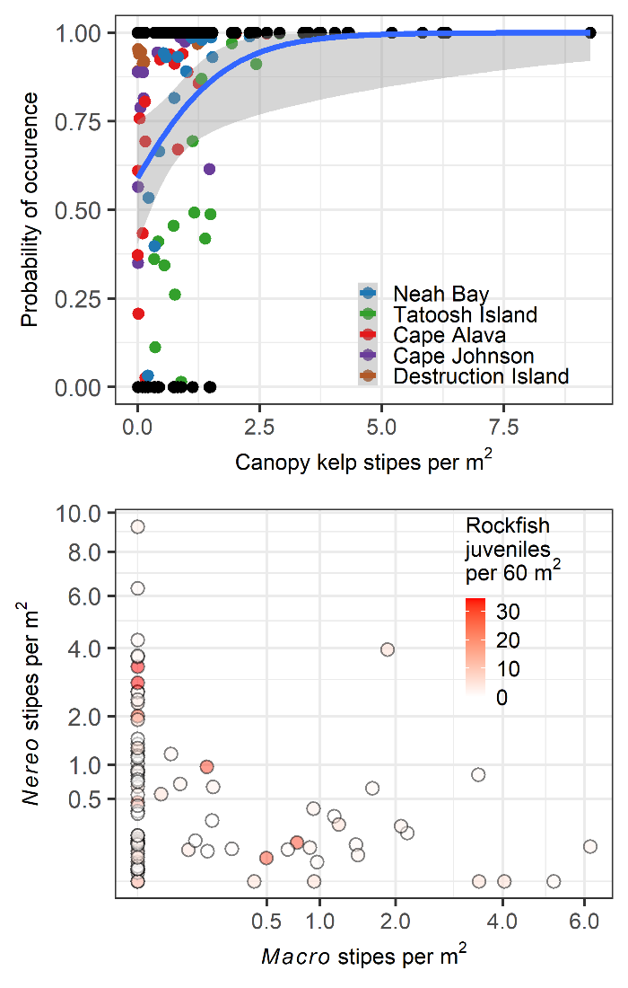

##### Figure 6. Relationship between kelp density and the abundance of juvenile rockfishes from the hurdle model. (a) Probability of occurrence of juvenile rockfishes in relation to the total stipe density of the canopy kelps *Macrocystis and Nereocystis*. Blue line shows the result of the binomial presence/absence model. Black points are the actual observations (present =1, absent = 0). Colored points are predicted probability of occurrence. (b) Results of the combined presence/absence model and abundance model. Larger circles have a higher probability of occurrence. Data were summarized by Site x Depth x Location x Year strata prior to analysis.